**OBE IMPLEMENTATION:DEPARTMENT SETTING**

###### ***by***

##### TEAM ARKA

##### ch.Harini(AP23110011191)

##### G.Hema Sri(AP23110011197)

##### K.Rishita(AP23110011202)

##### SK.Shabana Sultana(AP23110011204)

##### Kalyan Ram(AP23110011184)

##### Eswar(AP231100111187)

*A report for the CS204:Design and Analysis of Algorithm project*



DEPARTMENT OF COMPUTER SCIENCE AND ENGINEERING

**SRM UNIVERSITY AP::AMARAVATI**

**INDEX**

**Introduction 2**

Project Modules: 2

**Architecture Diagram 3**

**Module Description 4**

Programming Details naming conventions to be used: 4

Field/table details:(eg university)[you consider you module ] 5

Algorithm Details: 5

(i)Sorting 5

(ii)Searching 5

(ii) Storing the details in a text file 6

**Source Code 6**

**Comparison of Sorting Algorithms 7**

**Comparison of Searching Algorithms 8**

**Screen Shots 9**

**Conclusion 10**

# 

# 

# 

# 

# 

# 

# 

# 

# 

# Introduction

Our University (herewith considered as SRM-AP) is going to implement OBE(Outcome Based Education) in their university and you assigned in the project to develop an application with any programming Language you are well versed and you were supposed to do searching and sorting using learned algorithms,comparing your sorting algorithm with any one of existing algorithm,displaying the time complexity of both algorithms and explaining advantages and disadvantages of the algorithm.

## Project Modules:

Various Modules available in the project are

1.Blooms Level setting

2.Program Level Objective Setting

3.University

4.Schools

5.Department

6.Programs

7.Courses

8.Course objective setting

9.Course Outcome Setting

10.Course Articulation matrix Setting

11.Course Utilization Setting

12.Course Reference Setting.

# Architecture Diagram

***\*highlight your module***

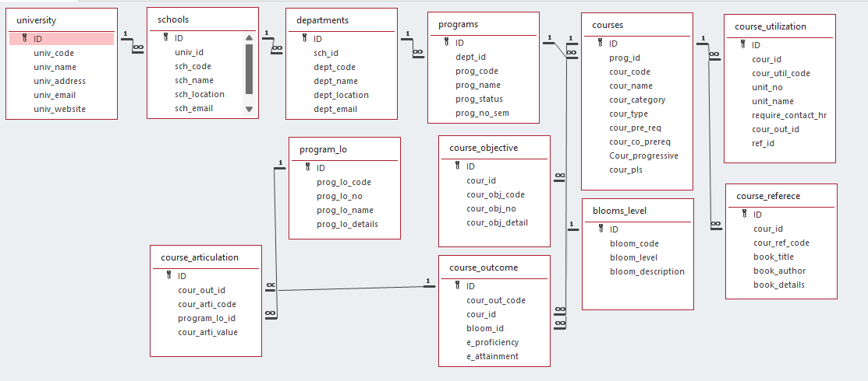

# Module Description

**Module Name:**Eg)university[you have to consider module given to you]

**Module Description:**

This module is used to create,Update,Retrieve,Delete(hereafter known as CURD) details of the module and storing the details in the text file.you have to provide option for searching and sorting of fields mentioned below according to algorithms given for you

## Programming Details naming conventions to be used:

* **File name:**yourregno_module_name
* **Function/method name**
  + **Create:**yourregno_module_name_create
  + **Update:**yourregno_module_name_update
  + **Retrieve:**yourregno_module_name_retrive
  + **Delete:**yourregno_module_name_delete
  + **Sorting:**yourregno_module_name_youralgorithm name
  + **Searching:**yourregno_module_name_youralgorithm name
  + **Storing:**yourregno_module_name_storing
  + **Comparison(both searching and Sorting)**:
    - For Searching-yourregno_module_name_Compare_Search_youralgorithm name
    - For Sorting-yourregno_module_name_Compare_sorting_youralgorithm name
  + **Time Complexity(both searching and Sorting):**
    - For Searching-yourregno_module_name_complexity_Search
    - For Sorting-yourregno_module_name_compexity_sorting
  + **Algorithm Details(pseudocode or steps)(both searching and Sorting):**
    - For Searching-yourregno_module_name_your_search_algorithmname_details
    - For Sorting-yourregno_module_name_your_sort_algorithmname_details
* **File name(for storing the details)**
  + File name to be used is:-university_setting .txt

## Field/table details:(eg university)[you consider you module ]

| **Field Name** | **Data type** |
| --- | --- |
| id | integer |
| univ_code | String |
| univ_name | String |
| univ_address | String |
| univ_email | String |
| univ_website | String |

## Algorithm Details:

### (i)Sorting

* You have to provide sorting based on **university code ,university_name , university_email.**
* Compare the algorithm you have used with any of the other sorting algorithm
* Display the time complexity of both algorithms.
* Display the pseudocode/algorithm of the sorting algorithm used by you

### (ii)Searching

* You have provide sorting based on **university code,university_name,university_email**
* Compare the algorithm used with any of the other algorithm you have learned
* Display the time complexity of both algorithms.
* Display the pseudocode/algorithm of the searching algorithm used by you.

### (ii) Storing the details in a text file

* Storing the details in the text file once details are entered.
* Delete the detail from the text file once details are deleted.
* Update the text file once details are updated.

# Source Code

# 

# 

# 

# 

# 

# 

# 

# 

# 

# 

# 

# 

# Comparison of Sorting Algorithms

# Comparison of Searching Algorithms

# Screen Shots

# Conclusion